GREEK HELSINKI MONITOR (GHM)

Address: P.O. Box 60820, GR-15304 Glyka Nera Tel.: (+30) 2103472259 Fax: (+30) 2106018760
e-mail: panayotedimitras@gmail.com website: https://greekhelsinki.wordpress.com

Communication on the execution of
Makaratzis group of cases (applications No. 50385/99 etc.)

27 September 2018

Use of potentially lethal force by the police in the absence of an adequate legislative and administrative framework governing the use of firearms (violation of positive obligation pursuant to Article 2 to protect life in the cases Makaratzis, Celniku, Karagiannopoulos and Leonidis); ill-treatment by police forces (violation of Article 3 in the cases of Bekos and Koutropoulos, Alsayed Allaham, Petropoulou-Tsakiris, Zelilof, Galotskin and Stefanou); treatment of coastguards amounting to an act of torture (violation of Article 3 in the case of Zontul); absence of effective investigations (procedural violations of Article 2 in the cases of Makaratzis, Celniku, Karagiannopoulos and of Article 3 in the cases of Bekos-Koutropoulos, Petropoulou-Tsakiris, Zelilof, Galotskin, Zontul and Sidiropoulos-Papakostas); failure to investigate whether or not racist motives on the part of the police may have played a role in some cases (violation of Article 14 combined with Article 3 in the cases of Bekos-Koutropoulos, Petropoulou-Tsakiris). The Galotskin, Stefanou and Sidiropoulos-Papakostas cases also concern the excessive length of criminal proceedings (violation of Article 6 § 1). Greek Helsinki Monitor (GHM) was the applicants’ representative before the ECtHR in nine of the twelve cases: Celniku, Karagiannopoulos, Leonidis, Bekos-Koutropoulos, Zelilof, Galotskin, Stefanou, Petropoulou-Tsakiris, Sidiropoulos-Papakostas. GHM submits the present communication both as a NGO working inter alia on reporting law enforcement abuses and as the representative of those applicants.

- Re-opening of investigations after 12 ECtHR judgments

In its 7 December 2017 decision, the Committee of Ministers (CM) first “invited the authorities to provide information on further developments and the outcome of the relevant procedure [the reopening of the disciplinary proceedings found to be inadequate and ineffective by the Court in the Zontul case], as well as information regarding the examination by the Ombudsman of the possibility of reopening administrative proceedings in the remaining cases of the group.” Greece has failed to provide such information, maybe because there is no known outcome in the reopening of the disciplinary proceedings in the Zontul case and there is no reopening of such proceedings in the remaining cases of the group, included the new Sidiropoulos-Papakostas case. The CM is requested to note that the relevant legislation has introduced a three- to six-month deadline for the completion of such investigations with an Ombudsman report, which has obviously been violated in the Zontul case for which the new investigation was launched one year ago and has yet to lead to a concluding Ombudsman report.

- Investigation of five cases previously reported to the Commissioner for Human Rights

In the same decision, the CM also “invited the authorities to provide further information about the results of the action undertaken by the Ombudsman in his capacity of mechanism for the investigation of arbitrary behaviour by law enforcement agents.” The CM is requested to recall that, in its 3 November 2017 communication to the CM, GHM brought to its attention six specific cases for which complaints had been filed to the Ombudsman. First, five well-documented cases that had triggered a letter of concern by the Commissioner for Human Rights to the Minister of Justice, Transparency and Human Rights and the Alternate Minister of Interior and Administrative Reconstruction on 18 April 2017: four cases of migrants, including minors, who claimed, inter alia, that they had been victims of severe beatings by police officers in Samos and Chios, in November 2016 and in January and February 2017; and the alleged severe beating, amounting to torture, of three Roma in October 2016 subjected to the above treatment by officers of the Western Attica Police Division. More than one and half year later, GHM and Advocates Abroad who had filed the complaints have not received any information about the investigation of these cases; nor has the Commissioner received any answer by the Ombudsman who was copied in that letter.

- Investigation of Kounanis’ and a dozen other cases previously reported to the CM

The CM is requested to also recall that in that submission, it was mentioned that another dozen ill-treatment allegations were the objects of complaints to the Ombudsman, but the plaintiffs never received any information about their investigation. Moreover, in the same communication to the CM, GHM detailed the case of the investigation of a complaint by George Kounanis, at the time a GHM Sexual Orientation and Gender Identity activist, victim of alleged homophobic harassment and offending behavior by police officers on 20 December 2015 in Athens’ Constitution Square. At the insistence of the Ombudsman, George Kounanis testified in March 2018 to a police officer who lacked objective impartiality as he belonged to the same police division with the alleged perpetrators, instead of being called by the Ombudsman to testify to them. For that case too, there is no information as to the result of the investigation by the Ombudsman.

Below GHM is providing documentation about “Unprecedented systematic police violence and illegal deportation of asylum seekers in Evros” with documentation of more than 400 cases, for many of which complaints to the Ombudsman were submitted but have not led to any concluding investigation (nor to any criminal investigation for that matter).

- Definition of torture and other legislative changes

In its December 2017 decision, the CM finally “noted the information about the establishment of a committee tasked with examining whether the definition of torture in Greek law is compatible with the definition in Article 1 of the UN Convention against Torture; also noted the information concerning the examination by the authorities of the matter of conversion of custodial sentences imposed for torture to ensure that that perpetrators of torture or ill-treatment are proportionately and effectively punished; invited the authorities to keep the Committee informed about further relevant developments.” GHM would like the CM to note that in the subsequently submitted report to UN CAT, on 19 January 2018, Greece reiterated the -timewise very vague- promise to possibly amend the definition of torture, but made no mention of any consideration of other legislative amendments to prevent the conversion of custodial sentences to fines and assure that perpetrators of torture or ill-treatment are proportionately and effectively punished, simply because that committee was not asked to propose such amendments and has not done so on its own initiative.

Ironically, a week later, on 25 January 2018, the ECtHR published its judgment in the Sidiropoulos-Papakostas case, finding Greece in violation of Article 3 ECHR in its procedural limb because: “La Cour estime en conséquence que le système pénal et disciplinaire, tel qu’il a été appliqué en l’espèce, s’est avéré loin d’être rigoureux et ne pouvait engendrer de force dissuasive susceptible d’assurer la prévention efficace d’actes illégaux tels que ceux dénoncés par les requérants. Dans les circonstances particulières de l’affaire, elle parvient ainsi à la conclusion que l’issue des procédures litigieuses contre le policier n’a pas offert un redressement approprié de l’atteinte portée à la valeur consacrée dans l’article 3 de la Convention.” It is to be recalled that the domestic judgment was the only final judgment in the Greek case-law under the felony dimension of torture (of two youth with a taser gun). Yet, the perpetrator police officer did not spend even one day in prison; he merely paid 5 euros per day for the 5-year custodial sentence imposed and converted to a fine to be paid in 36 monthly installments! A sentence to more than 5 years could not be converted to a fine; the low sentence imposed aimed to avoid his imprisonment!

- Apparent failure to effectively investigate the death of an Albanian in a police station

GHM would like to add a new case indicative of the reluctance of Greek authorities to investigate allegations of police violence and other abuses. On 3 August 2016, 28-year old Albanian Pellumb Marnikollaj went to the police station of Patisia (Aghias Lavras street in Athens) as required to do regularly by a court parole decision. There he died. Police claimed that he jumped from the second floor; except that that police announcement was made a fortnight later, on 18 August 2016! In the meantime, authorities had failed to inform anyone and the victim’s relatives located the corpse only on 11 August just before it was to be buried as unclaimed. The body also examined by a forensic in Albania reportedly had stains that could have been caused by ill-treatment if not torture. This is why Albania’s Prime Minister Edi Rama posted on 16 August 2016 his concern on his Facebook account. Greek police investigation was either not carried out or was summarily concluded that there was no wrongdoing. The family’s lawyers informed GHM that the judge assigned to conduct a criminal judicial inquiry did not carry any acts of investigation and returned the court file to the prosecutor two years later recommending the archiving of the case!

- Unprecedented systematic police violence & illegal deportation of asylum seekers in Evros

On 9 September 2018, GHM send to the Commissioner for Human Rights the extensive report appended here, urging her to write to the Greek authorities asking them to promptly and efficiently investigate each one of the at least 410 individual or group claims of ill-treatment and/or illegal destruction of documents and/or deportation listed below, an investigation to be assigned to one (or more) Supreme Court Deputy Prosecutor(s) or Athens Appeals Court Prosecutor(s) for the criminal aspect and the Greek Ombudsman for the administrative aspect, so that the results of these investigations are also made available to CPT during its 2019 periodic visit and to the UN Committee against Torture (CAT) during its July-August 2019 examination of Greece.

The report includes information from CPT and NGOs (who have contact with the victims) that indicates a prevailing systematic use of violence by law enforcement forces in the Evros land border area with Turkey usually followed by illegal deportation of persons without allowing them to file for asylum while, at the same time, destroying these persons’ personal items and documents. As said in one case, this method is used by Greek authorities as a deterrent. GHM believes that these are just the tip of the iceberg and that the total number of victims may be in the thousands. Such extent of law enforcement violence is unprecedented since 1974.

Conclusion

The CM is requested to ask Greece specific information about:
- The re-opening of investigations after the 12 ECtHR judgments
- The investigation of five cases previously reported to the Commissioner for Human Rights
- The investigation of Kounanis’ and a dozen other cases previously reported to the CM
- The investigation of the death of an Albanian in a police station
- The investigation of 410+ documented cases of police violence and illegal deportations of asylum seekers in Evros
- The developments in the amendments to the definition of torture and other legislative changes to assure that perpetrators of torture and ill-treatment are effectively punished.
APPENDIX

Unprecedented systematic police violence and illegal deportation of asylum seekers in Evros

September 2018

1-15. Ill-treatment and push-backs of 15 persons documented by CPT

Preliminary observations made by the delegation of the European Committee for the Prevention of Torture and Inhuman or Degrading Treatment or Punishment (CPT) which visited Greece from 10 to 19 April 2018 (published on 1 June 2018)

(…) 24. The delegation received several consistent and credible allegations of informal forcible removals (push-backs) of foreign nationals by boat from Greece to Turkey at the Evros River border by masked Greek police and border guards or (para-)military commandos. In a number of these cases, the persons concerned alleged that they had been ill-treated and, in particular, subjected to baton blows after they had been made to kneel face-down on the boat during the push-back operations. These allegations, which were obtained through individual interviews with 15 foreign nationals carried out in private, all displayed a similar pattern and mainly referred to incidents that had taken place between January and early March 2018, whereas some dated back to 2017. The persons who alleged that they had been pushed back from Greece to Turkey had again entered Greek territory, and had subsequently been apprehended by the Greek police. The report will elaborate further on the issue of push-back operations.

16-28. Photographic evidence of ill-treatment of 13 persons supplied by Alaa Hasan

VIDEO UPLOADED BY ALAA HASAN, CIVIL SOCIETY ACTOR ASSISTING REFUGEES

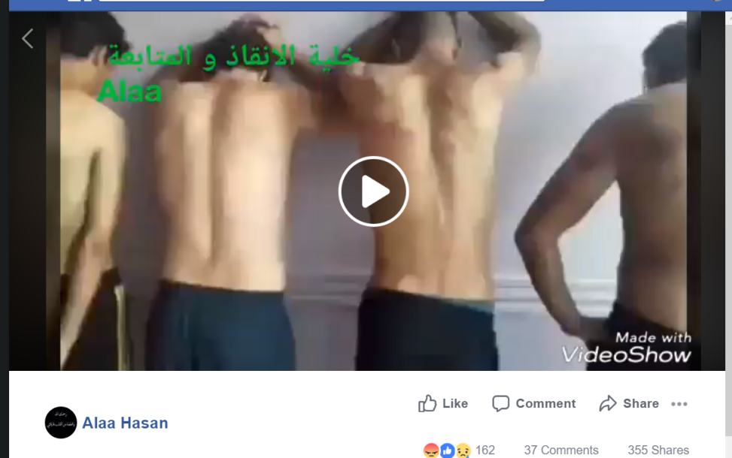
Please watch the video available at: https://www.facebook.com/ali.surveyor.7/videos/902061989990095/ (also on file with GHM)
The five persons in the video above, according to Alaa Hasan, were arrested by Greek Police at the red pointer near Mavrokklisi, Evros on 11 August 2018 (see map below extracted from https://www.google.com/maps/place/41°20'20.2"N+26°17'29.6"E/@41.3402058,26.2738952,2568m/data=!3m1!1e3!4m5!3m4!1s0x0:0x0!8m2!3d41.338945!4d26.291543).
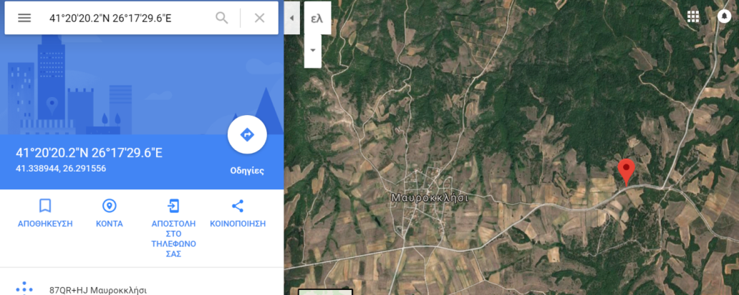
Their phones, passports and money were taken by the Greek police; they were not allowed to apply for asylum or to speak even in the place of detention; and they were subjected to violence, whose results are shown in the video shot in Istanbul. They are from Syria, Palestine and Iraq. Alaa Hasan has additional statements by others who told him that they were detained for 24 hours without food or water before being illegally deported to Turkey, again after phones, passports and money taken away from them, who were also ill-treated. In addition to the five persons shown in the video, the group includes four more persons with similar signs of ill-treatment who did not want to be videotaped.

FIVE PICTURES PROVIDED BY ALAA HASAN, CIVIL SOCIETY ACTOR ASSISTING REFUGEES
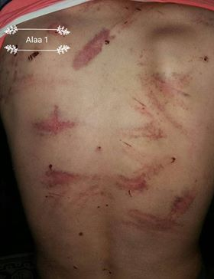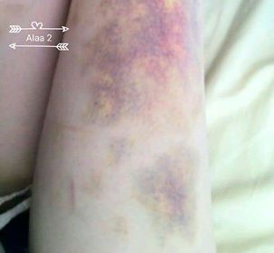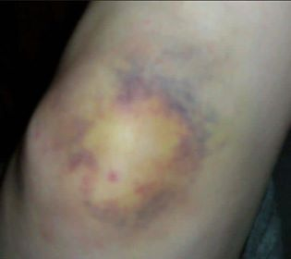
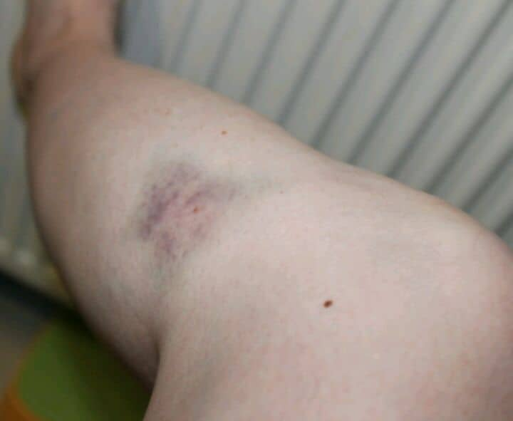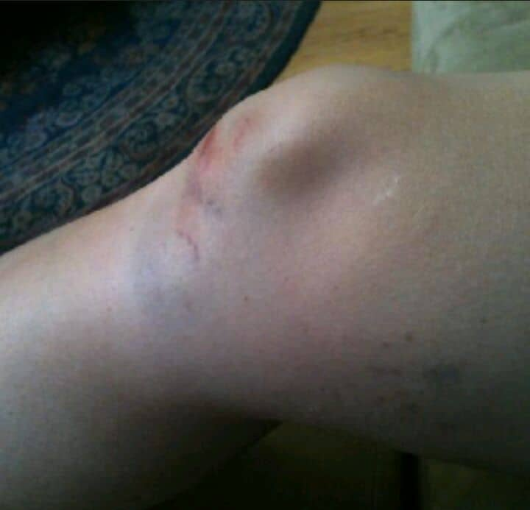

These are five pictures of a woman from Syria who entered Greece in the Evros area with her three children before 11 August 2018, and was severely beaten by Greek police before being summarily and illegally deported to Turkey.

All thirteen persons mentioned are in Istanbul, according to Alaa Hasan.

29-152. Ill-treatment and illegal deportations of 124 Syrian asylum seekers reported by Advocates Abroad
Advocates Abroad has information on violation of rights including ill-treatment by police and/or border guards and illegal deportations of 124 Syrian asylum seekers, between July 2018 and as early as December 2015, in the Evros land border with Turkey. Advocates submitted three separate complaints to the Ombudsman on behalf of those individuals. All the cases that Advocates submitted to the Ombudsman were deemed admissible, and investigations are ongoing for all three cases. Advocates will file more complaints in upcoming weeks. Here are three postings published on the Advocates Abroad official Facebook page:

Advocates Abroad
August 17 at 8:56 AM ·
A few sections from the complaint filed by Advocates Abroad to the #Greek #Ombudsman concerning illegal #deportations of #refugees and #asylumseekers: "This complaint concerns an illegal deportation undertaken by the Hellenic Police of xx refugees from xx, Greece to #Erdine, #Turkey on -- -- 2018. The group had crossed into Greece via #Evros River in the early morning. Within twelve hours, they had been arrested by the police, brought to the ----- station for hours of abuse and interrogation, bussed back to the border, and finally forced onto a boat which returned them to Turkey. This entry and exit happened all on the same day. The matter at hand is alarming, well-evidenced, and of critical importance for too many vulnerable refugees on the Greek borders. On behalf of those individuals and the attorneys of Advocates Abroad, I urge your office to immediately and fully investigate this matter...Several times during detainment, the police were informed by the group that they were seeking asylum and wished immediately to lodge an application to the Greek Asylum Service. They made the request several times to several officers during the day, and thus established clearly their intent to seek asylum. These individuals could not have possibly been afforded all their right of asylum and also have been returned in the period of a single day; accordingly, under both international and national law, this removal is illegal. Furthermore, many personal items, including passports and phones, were also illegally seized and not returned.

Advocates Abroad
August 22 at 1:47 AM ·

We have just filed another complaint to the #Greek #Ombudsman on behalf of another young Syrian who was illegally deported with 46 other Syrians from Greece to Turkey, in the #Evros region. He was then illegally deported from #Turkey to #Syria. His case is one of many that are crowding our inboxes these past days, all serious, deeply alarming allegations against the Hellenic and Turkish police forces. These two forces stand accused of violent tactic, including measures such as locking refugees in minibuses until all near perished from suffocation, beating publicly elderly refugees near death as a warning, and shooting around the refugees to force them to stop fleeing. This is just the surface. This is just one case. We have all heard of illegal deportations from Greece and Turkey, but we do not know or appreciate the number of such cases. It is our duty to find and help these people and to end such tyrannical practices on borders.

Advocates Abroad
August 23 at 1:20 AM ·
Tonight, we filed a third complaint to the #GreekOmbudsman on behalf of an illegally deported #Syrian husband and wife from #Evros Region by the #HellenicPolice. There were 60 individuals in the group removed to #Edirne, Turkey. The total time that the husband & wife pair spent in Greece? 24 hours. It is difficult to get someone registered in that little time, let alone registered, interviewed, case decided, appealed, decided again, appealed again, and legal return implemented. It is offensive to permit such illegality, and Greek authorities must take better care of their own offices to ensure such flagrant abuses do not occur on their watch. The group had not used a smuggler to arrive, and had fled over the border because border guards were shooting at them from behind. After arrival and arrest by Hellenic police, the group suffered unique abuses and humiliations, such as forcible stripping down to complete nudity so their clothes could be "checked." Their phones, as usual for such situations, were seized and not returned by the police. A mother was denied water to make milk for her newborn. Threats were made that the refugees would be shot if they disobeyed an order from the police.

153-254. Ill-treatment and illegal deportations of 101 persons reported by Refugee InfoBus

INFORMATION PROVIDED BY REFUGEE INFOR BUS
Case # | Date Event Took Place | Location | Further Information | Organisations this event reported to | Other Notes
4 | 5 July 2018 (Reported to Refugee Info Bus on 31 July 2018) | Evros Border - we have specific locations | Two groups, one consisting of 14 refugees and another one consisting of 19, who are refugees from Syria, Yemen and Iraq, tried to seek asylum in Greece. Upon arrival and they were taken by police, they had their passports, money, phones and shoes taken from them and then forcibly deported back to Turkey. They were not given the chance to claim asylum. | GCR, UNHCR, Amnesty, Greek Ombudsman via email. Refugee Rights Turkey. | We were told about this group through Alaa Hassan - they had already reported the incident to alarm phone - this sparked one of the reasons to set up this table - we have further details and members of the groups contact numbers if it is needed for further investigations/report writing
5 | 27 June 2018 (Reported to Refugee Info Bus on 28 July 2018) | Arriana - 100 km into Evros Region | “we were a group of four people ready to cross the river Evros to Greece, and after 9 days of walking through the mountains we get down to have some food and water, hungry and covered in mud, the police saw us and we were taken to a different area, in which were held for 2 days, we have been told we will get a chance to claim asylum in Greece, and what makes me believe them is the sign on the front of the building saying that this point funding by 75% of EU and 25% of Greece government as I remember, we were 40 persons and two families in the same place, after 5 hours they sheft them to another room, no food and just water” Ameer said.  “after 2 days of waiting to get the chance to claim asylum, around the 10 pm two busses sheft us to the border, and with small boat one for the two families and two for the others have been sent back to Turkey, upon arrival at the Turkish side, the Turkish police came and collected us” Ameer said.  People are experiencing these degrading acts of violence but for fear of reprisal or lack of evidence, justice is not being served and border patrol agents or police continue to act with impunity.  Ameer continued “we were sent to the UNHCR camps in Turkey, and after that they sort by nationality, according to the Turkish policy Yemenis and Palestinians can stay and get free in Istanbul and the others have two choices even go to jail for one year or accept the deportation, since I and Muhammad are Iraqis we signed to be deported, Abdullatif is Yemeni and I contact with him and he told me they are in Istanbul now”.  There were 2 Syrians with them, they don't know anything about them.  “It's hard to stay in Istanbul since there is no support at all from the Turkish government, I don't have documents, I am survive because of my friend who invited me to stay with him, he is taking care of me.” | GCR, UNHCR, Amnesty, Greek Ombudsman via email, Refugee Rights Turkey. | We are in touch with the two men from Iraq who wish to take legal action, who have deported themselves voluntarily.
6 | 15 March 2018 (Reported to Refugee Info Bus on 10 August 2018) | Evros Border - we have specific locations | I travelled with a smuggler we were 42 people and with us was a lady who was eight months pregnant. We crossed the river and arrived near the village of Soufli. the pregnant lady was travelling on her own, she tried to call her husband who was in Greece to ask for an ambulance for her, the smuggler does not let her call her husband and asked an old lady to see if she really need an ambulance or not and she said that she is just tired of walking and no need for ambulance.  However, the rest of us hid and waited for a car to take us out of the region and into Greece. Then the police caught us, and I ran away, but they started to shoot us and we hid in the forest. I walked on my own to the nearest train station and bought a ticket online. The ticket master took my ticket and handed me over to the police and imprisoned me for the whole day without food and water with 20 people in the cell. Then I was given food the next day but I didn’t eat until sunset. At about 12 o’clock in the night the cell was opened and everyone started being taken out of the cell, I was late as I was putting on my shoes because I took so long, I was beaten really badly on my hands and elbows. They stole our things, took us in a boat, and dropped us off at the other side of the river without our telephones and without any food or water." | No legal action taken on behalf of this man yet - he doesn't know what happened to the rest of the group and he wants to try again to enter Europe (he is now in Turkey). | We are in contact with the individual who wants to remain anonymous and who this happened to. We would like guidance about what to do about this case - without damaging the man’s desire to remain anonymous and not wanting to come forward.
7 | 20 March 2017 (Reported to Refugee Info Bus on 12 August 2018) | Thessaloniki | I had been in Germany for more than a year and have received temporary protection from Ozavis  I also challenged the decision to amend it to full leave to remain. I travelled on my Ozavis to Greece to see my friends and was caught by the Greek Police. We were arrested and taken by police to an area more than three hours away from Thessaloniki. Then the police officer took away our papers, searched us, interrogated us and promised to return us to Germany. Instead, they took our papers, searched us and interrogated us and then sent us across a river to Turkey. I still have the Ozavis - I am stuck in Turkey and need to get back to my children in Germany.
8 | 15/07/2017 | Evros Region | Group of mainly Palestinian men really badly beaten and had their money stolen, documents stolen and thrown back into Turkey in the middle of the night - they are featured in now well circulated video of police beatings. [GHM note: possibly referring to Alaa Hasan report above] |  | We are in contact with one man who experienced these beatings who speaks excellent English - they have decided to stay in Istanbul and this man in particular wants to ensure that what happened to them doesn't happen to anyone else. They expressed explicit interest in going public to ensure this doesn’t happen again.
9 | 18/07/2017 (Reported to Refugee Info Bus on 24 August 2018) | Evros Region | Syrian man violently pushed back to Turkey, phone stolen, having taken the train from the village of Orestiada train station in Greece. | GCR | Young man trying again
10 | (Reported to Refugee Info Bus on 23 August 2018) |  | 20 year old Syrian man hospitalised for a week having been beaten up by Greek police, and having had his phone stolen, his Syrian passport and also 7000 euros of Cash. His Dad contacted us first who is in Germany - his dad is of course absolutely devastated and so worried about him. | GCR | Boy was thinking of trying again but also wanted to know if there were any legal ways for him to get to Germany to his Dad, of course now a police officer have all his money it will be so much more difficult for him to go.

255-260. Ill-treatment and illegal deportations of 6 persons reported by Refucomm

INTERVIEW OF MINA TO REFUCOMM, IN LATE AUGIST 2018
“Today, I want to talk about a horrific experience I went through. This is about our compulsory return. My concern is not about being returned, it is rather about how we were treated. …once we entered Greece, in late July 2018, we ended up in Orestiada. We wanted to hire a taxi to Thessaloniki but we were told by people that we should get registered first. We were told after the registration we would be given some documents to show we were refugees here. We went to the police and explained our situation. They asked us where we were from and we said we were Iranians. They told us to wait there for border officers. After a while, we saw a van. A couple of ununiformed men took us to the van. Once we were inside they closed the door. There was no air and we couldn’t breathe properly. After a while, they opened the door and soon we found ourselves in a cell without food and water. We were pleading for their attention. We were reasoning with them that we were humans and we only came her because we had heard Europe was ruled by human rights. But no one was listening. They took away all our belongings such as money, mobile phones, clothes and even our shoe laces. We spent the night in the cell and the next day, in the afternoon a man came and asked us to get into a van. This time there were other people with us (about 18 men and women). There was no air to breathe and we were at the edge of suffocation. We could feel we were coming out of the city as our ride was getting bumpier. Finally the van stopped and the door opened. I could see a river. It was here that I saw the most dreadful treatment of refugees. Men with thick sticks started beating refugees in the most inhumane way. The torture was not only physical, it was emotional too. I could see our belongings in a separate van close to us but they wouldn’t let us touch them. We were absolutely exhausted. We were there for hours without water, food, beaten and in pain. They made us lay on the ground until a few small black inflatable boats arrived. They pushed every six of us into one boat. Once we were stuffed into them, I saw they threw all our belongings into the water. On the way, people attempted to ask questions but they were silenced with threatening gestures. We were scared, they had guns with them. The air was getting dark. No one had a watch to see what time it was. It was after hours that we noticed they were about to let us go. We were literally in a jungle. Once we were out of the boats, we were shaken by two shots in the air. Was it some type of code between them and the Turkish border police? I don’t know. It was dark and the jungle was wild and scary. We were wondering around trying to find our way out of it anxiously. In the end we saw a rough road that looked more like a dusty path. We walked through and finally saw the border officers. We were detained once more. We explained everything. In contrary to our expectations, the police were quite calm about it. They in a careless manner confirmed everything we had experienced by saying they were aware of the atrocities. They said they were catching hundreds of returnees with broken arms and legs. They even showed us a picture of a refugee who was badly tortured. The only piece of advice they gave us was not to put ourselves though all this by going to Europe”! This is how she described her experience. When I asked about the nationality of refugees, she said that they belonged to variety of countries such as philistine, Syria, Iran, Sudan and even Turkey. Surprisingly, the Turkish were not returned. The following are screenshots of WhatsApp exchange supplied by Refucomm.

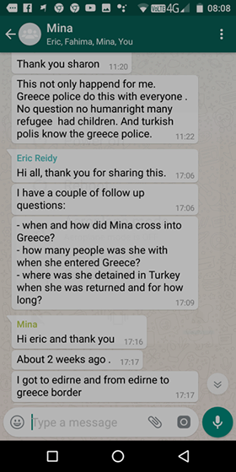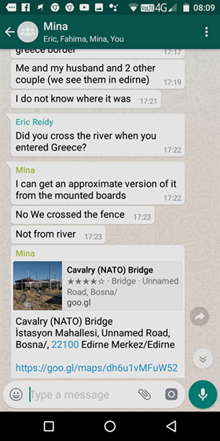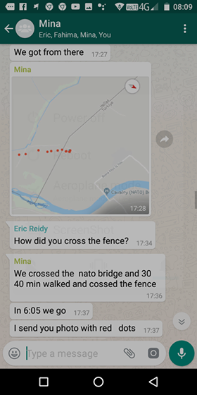
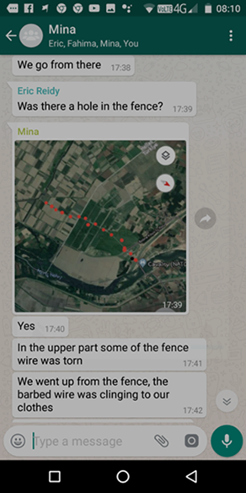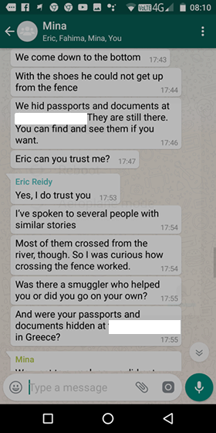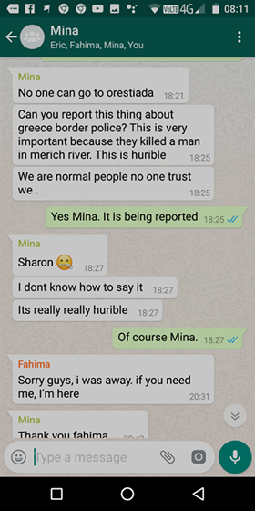

261-342. Ill-treatment and illegal deportations of 6 persons reported by Watch the Med

INFORMATION PUBLISHED BY WATCH THE MED

30/06: 10 people at Turkish/Greek land border – pushed back to Turkey!
VERIFIED
In Distress Push-Back
01.07.2018 / 11:44 / Greek-Turkish Land Border
Watch The Med Alarm Phone Investigations – 30th of June 2018
http://watchthemed.net/index.php/reports/view/934 and https://www.facebook.com/watchthemed.alarmphone/photos/a.1526182797655958.1073741828.1525906057683632/2144083675865864/?type=3&theater
Case name: 2018_06_30-AEG401
Situation: Distress situation at Evros land border
Status of WTM Investigation: Open
Place of Incident: Evros Region
Summary of the Case: On Saturday, the 30th of June 2018, at 4.30am, the Alarm Phone was informed by a contact person about a group of people at the Turkish-Greek land border, in need of support. We were told that the communication between the contact person and the travellers had broken down, but we received a list of their names. Five of them were from Syria, five from Sierra Leone, six men, two women, and two children. We contacted the travellers, received their GPS position, and notified the police to their whereabouts, as the travellers had asked us to do. We also informed the UNHCR Greece. At 6.44am we received the information that one of the children had a liver problem and suffered a lot due to the cold. Afterwards we lost contact to the travellers. At 8.56am, the regional police station informed us that they had been searching for 2 hours but had not been able to find them.

At 1.45pm we received a message from the contact person that had initially alerted us to the case. He said that the Greek officers had beaten the travellers and stolen their phones. Apparently, they had been forced onto a boat and returned to the Turkish side, across the Evros river. We tried to contact the UNHCR but were unable to reach them. We were able to contact one of the members of the group of travellers at 2.18pm, who had been able to hide her phone. She told us that they were on their way back to Istanbul. They had been beaten up by people in blue and black uniforms at about 9am local time. Their belongings had been taken away, and at least 5 of them had been forced back to Turkey by boat. They had not taken any pictures as their phones had been taken away. They were kept in confinement in Greece for about one hour and treated badly, “like dogs” she said, before being forced onto a boat that returned them illegally to Turkey. At 3.20pm, she confirmed to us that those who had attacked and pushed them back had been Greek authorities. At 4.05pm, she told us that she was now on a bus and would arrive in Istanbul in the evening. In a short statement we denounced this serious violation of the group's basic human rights and demanded immediate actions to stop these illegal push back practices at the Turkish-Greek border.

05/07: Two groups at the Turkish-Greek landborder, 14 travellers pushed back
VERIFIED
In Distress Push-Back
06.07.2018 / 22:23 / Turkey - Greece land border
Watch The Med Alarm Phone Investigations – 5th of July 2018
http://watchthemed.net/index.php/reports/view/942
Case name: 2018_07_05-AEG405
Situation: Two groups at the Turkish-Greek landborder, 14 travellers pushed back to Turkey
Status of WTM Investigation: Concluded
Place of Incident: Turkish-Greek landborder
Summary of the Cases: On Thursday, 5th of July, The Alarm Phone assisted two groups of travellers in the Turkish-Greek border zone. One group of 14 travellers was pushed back to Turkey.
At 8:46am CEST, we were alerted to a group of 14 people in a forest close to the Greek town Didimoteicho and the landborder to Turkey, among them 3 women and 2 children. We couldn’t establish a connection to the group as their phone was switched off. At 11:04am, the contact person forwarded us a new position. After managing to reach the group, we informed the NGO Greek Council for Refugees (GCR) at 12:31am and sent them a list with the names of the travellers. At 1:28pm the GCR informed us that they had contacted the group and informed local and regional authorities as well as the UNHCR. At 2:43pm the group informed us that still no assistance had arrived. We informed the GCR and asked the group to call 112 in case of emergency. At 3:40pm GCR informed us that the police would send a patrol car. The group had moved and sent us their actual position which we transferred to GCR. GCR informed the police. At 4pm the contact person informed us that the police had found the group. In the ongoing, we tried to establish contact to the group, but couldn’t reach them any more. Only at 9pm we received new information via the contact person: Reportedly, the police had brought the people back to the border with Turkey and left them on a small islet in the midlle of Evros river without any help. The group reported about violent treatment by the police and that most phones had been confiscated and destroyed. At 9:21 we received their new GPS position. At 10:10pm the group informed us that they were back in Istanbul, Turkey.
At 4pm CEST we were alerted to a group of 12 people stuck in Evros river border zone near Mikrochori, Greece. The group consisted of 8 men, 2 women and 2 children. They were asking for assistance and international protection. We asked them to send us a list of their names. At 6:07pm we received the list. At 6:35am the travellers called us and asked us to alert the authorities to their situation. We hence tried to reach UNHCR Athens, UNHCR Thessaloniki and the Greek Refugee Council, but couldn’t reach any office. At 7:23pm we sent an email to the authorities informing about the group. At 7:43pm we called the local police station but couldn’t reach anyone. At 8pm we established contact to the police call center and passed all relevant information. We sent emails to all police stations in the area to inform them about the presence of the group. At 8:39pm the people contacted us; they hadn’t been found yet. At 10:17pm we called the Evros Police Center again, but they didn’t have news. At 10:21pm the travellers called to inform us that the police had arrived. They were trying to claim asylum. We asked the travellers to inform the police that various organisations in Greece, including UNHCR, had been alerted about them. We sent an email to all police authorities in the area as well as to UNHCR, emphasizing that a push-back of the group to Turkey would be illegal. At 11:45pm we called the police center to investigate but didn’t get information. We couldn’t establish anymore a connection to the travellers and couldn’t find out anything contacting the local authorities and UNHCR. It remained unconfirmed what happened to the group.

08/07: 19 travellers at Turkish-Greek landborder, pushed-back to Turkey
VERIFIED
In Distress Push-Back
09.07.2018 / 22:30 / Turkey - Greece land border
Watch The Med Alarm Phone Investigations – 8th of July 2018
http://watchthemed.net/index.php/reports/view/943
Case name: 2018_07_08-AEG406
Situation: 19 travellers at Turkish-Greek landborder, pushed-back to Turkey
Status of WTM Investigation: Concluded
Place of Incident: Aegean Sea
Summary of the Case: On Sunday, 8th of July, at 11:14pm CEST, we were alerted to a group of travellers stuck near Tichero, Greece, close to the Turkish landborder. The group consisted of 19 people, among them a 1-year-old child, a pregnant lady and a man that had a broken leg. At 12:11pm we managed to establish contact to the travellers. They were afraid of being pushed-back to Turkey by the police and asked for medical aid and the possibility to seek asylum in Greece. We asked them for a list of their names and birth dates in order to alert UNHCR. At 1:02am we received the list. We couldn’t get back in contact until 1:47am. The group decided not to move further and to wait until the morning for the UNHCR office to open so they could call there.

At 8:30am we called UNHCR and asked for assistance. At 8:45am we also called the local police station but the operator refused to speak to us in English. We told the group to call 112 themselves for assistance. Until 9:30am we couldn’t reach any local police station. At 9:50am we sent an email to the local authorities and UNHCR to inform them about the people. Afterwards we continuously tried again to get in touch with the authorities and the group, but couldn’t establish a connection any more. At 2pm we reached the police in Alexandropolis. They informed us that they were searching since one hour but hadn’t found the travellers. During the afternoon, we couldn’t get any news and didn’t reach the travellers anymore. At 6:53pm the police informed us that they had not found the group yet. The next day at 11:02am we were informed by a contact person that the group had been found and that they had been allegedly violently pushed-back to Turkey. At 12:45am we managed to reach the group itself. They told us that the police had found them at 5:00pm the day before and put them in „a prison“. At 10:00pm the police had told the group that they were being moved to a camp to apply for international protection. However, the police instead brought them back to the river and handed them to officers described as „military“, who forced them onto a boat and across Evros border river back to Turkey. The police officers before had confiscated personal belongings of the refugees, including mobile phones, money, passports and the food for the baby.

21/07: AEG- 27 people missing at Greek/Turkish landborder > Push-back
VERIFIED
In Distress Push-Back
22.07.2018 / 20:51 / Aegean Sea
Watch The Med Alarm Phone Investigations – 21st of July 2018
Case name: 2018_07_21-AEG-406
Situation: 27 people missing at Greek/Turkish landborder > Push-back
Status of WTM Investigation: Concluded
Place of Incident: Aegean Sea
http://watchthemed.net/index.php/reports/view/955
Summary of the Case: On Saturday, July 21, at 19.28 CET, The Alarm Phone received a message from a contact person indicating that 27 people had been missing for 3 days near the Greek/Turkish landborder being left without food and water.. The shift team immediately contacted the relevant actors in the region, including UNHCR, and learned that the Greek Border Police was reportedly already looking for the group. The following day, the shift team received information that parts of the group had been pushed back to Turkey and that their shoes and other belongings had been taken away or broken by the Greek authorities. The shift team maintained contact with a contact person as well as relevant NGO and International Organizations. The contact person alerted the shift team at 16.50 on July 22 that 12 travellers were in a Turkish detention centre, including her brother and sister. On July 23, The Alarm Phone was able to speak to one person from the returned and confirm that they had been pushed back to Turkey. The Alarm Phone was not able to gain information about all travellers in the group, as several have disappeared after the Turkish authorities appeared and started arresting them. Allegedly, some could escape but at least one person of the arrested got reportedly returned to Syria. A follow-up is still ongoing. Among the group were two kids, two women and two sick persons.

343-344. Ill-treatment and illegal deportations of 2 persons reported by Infomigrants

INFORMATION PUBLISHED BY INFOMIGRANTS
Greek authorities accused of illegal pushbacks and violence against migrants
By InfoMigrants Marion MacGregor | Latest update : 2018/08/29
http://www.infomigrants.net/en/post/11579/greek-authorities-accused-of-illegal-pushbacks-and-violence-against-migrants

Growing numbers of migrants are trying to enter Greece via land routes from Turkey. At the same time, there are reports that Greek authorities are using practices including forced expulsions of migrants back across the border. InfoMigrants has received a video secretly filmed by a man who says he was the victim of such an operation.
Kurdish journalist Hiwa Dartas and his wife Danaz did not expect that their journey of escape from northern Iraq to Europe would be easy. But had they known that upon reaching Greece they would be caught and locked in a small room without their belongings, and later taken by masked commandos back across the border into Turkey, they might have made different plans.
"The prison was 2x4 meters in the middle of nowhere. People were urinating, defecating, sleeping and resting all in this room, where you can see the urine bottle in (the) video.
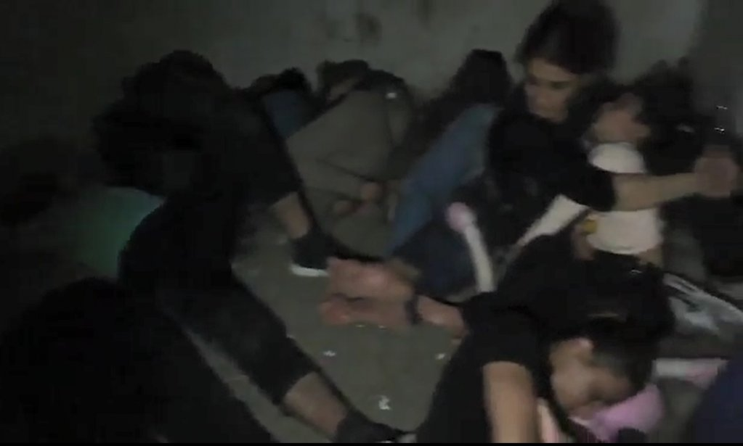
Screenshot from cellphone footage taken by Hiwa Dartas
"They took the women and the children out of the room. Soon afterwards they brought 50 more people inside. The oxygen was almost finished in the room. We tried to break the door and this is when they came in and hit us. They opened the door for a couple of minutes.
"In the afternoon, some other commandos came with masks and divided us into groups of men and women and sent us back to the Turkish border in an illegal boat after taking all food, water, bags, belts and shoes from us. They shot into the air to let the Turkish army know there were people on their side."

Hiwa and Danaz Dartas say while they managed to escape arrest in Turkey, more than 90 others who were also forcibly expelled by Greek authorities on that day less than a fortnight ago were not so lucky.

Pushbacks increasing: Report

Stories of such treatment by Greek authorities have become increasingly common, according to the Greek Council for Refugees (GCR). Earlier this year, the Council published a report which included a large number of testimonies of what it calls illegal pushbacks of refugees in Evros on the Turkish border.

It claims Greek authorities are systematically arresting and detaining people in need of international protection, "asylum-seekers and even recognized refugees," and sending them back to Turkey.
Pushbacks are a means of stopping refugees and migrants at borders and forcibly turning them around to the country they came from. The legal term is collective expulsion -- a practice prohibited by Article 4 of Protocol 4 (Art 4-4) to the European Convention on Human Rights.

Under international law, countries have an obligation to process asylum requests. They also can't force a group of migrants to leave before they have properly assessed the case of each individual. If it comes to expulsion, Art 4-4 gives them the right to contest the move.

'Deplorable conditions and violence'
The GCR report claims that the victims of pushbacks include vulnerable migrants such as pregnant women, people who have been subjected to torture, and children. It identifies what it calls a specific "pattern" of operating in which authorities transfer migrants to detention centers where there are armed guards, sometimes wearing Greek police uniforms, military-style camouflage or with face masks. According to the report, when the migrants are arrested, their cellphones, money, ID cards and legal residence documents are confiscated and never returned.
The GCR says this has happened to undocumented arrivals who have not had an opportunity to seek international protection, but also to people who have applied for asylum in Greece and even those who have already been granted protection in another European country, yet still attempt to enter Greece by irregular means.
Burden on Greece
While migrant arrivals in Europe are well down compared with the huge influx in 2015, the burden on Greece as a front-line country remains significant. In the first half of this year, Greek authorities reported 22,899 arrivals, more than twice as many as in the same period last year and more than any other country in Europe.

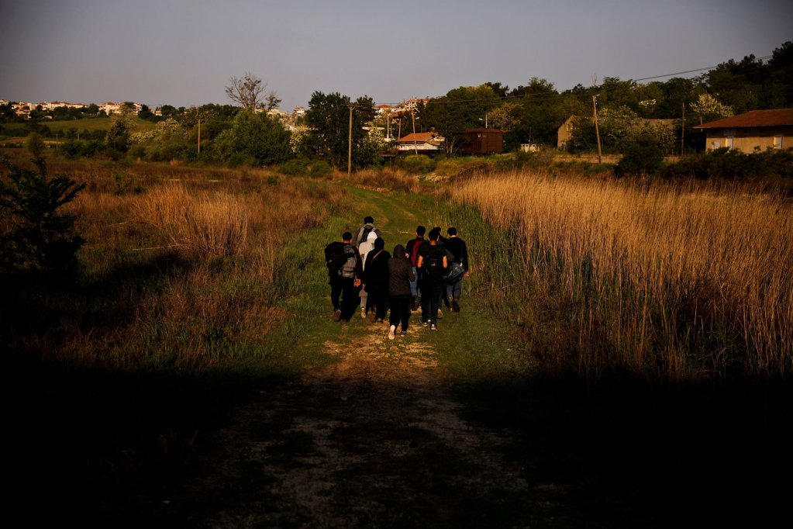
The plight of Syrian refugees continues - as the one of this group of Syrians in Greece after having crossed the Evros river
in April 2018 | Credit: REUTERS
Arrival patterns are also changing. With the sea routes to the Greek Islands now largely blocked, more migrants are attempting to cross overland from Turkey. Since January, 9,385 people have crossed into Greece through its land border with Turkey. And according to the International Organization for Migration, the proportion of irregular crossings by land routes is rising at a rapid rate.

Greece accused of breaching international law

Greece is certainly under pressure, but claims that it is using pushbacks have provoked alarm in many quarters, including the Council of Europe and the UN refugee agency. Greek legal experts say the practice violates the country's international obligations and specifically the principle of nonrefoulement and the right of access to asylum. The GCR also says it constitutes inhuman or degrading treatment and exposure to threat to life or risk of torture.

The principle of non-refoulement is enshrined in the Geneva Convention and means that refugees can't be returned to a place where their life or freedom would be threatened. Though it has not been possible to obtain independent evidence to support Hiwa Dartas' account, if true, it would be a case in point.

InfoMigrants contacted the Greek Ministry for Migration Policy for comment specifically on the claims of pushbacks but received no response.

According to Kleio Nikolopoulou, a GCR lawyer, the authorities do not acknowledge that pushbacks are happening.

Hiwa and Danaz Dartas, meanwhile, are planning their next attempt to make the crossing into Greece. This time, they'll know a bit more about what to expect.

345-358. Ill-treatment and illegal deportations of 6 persons reported by Human Rights Watch

INFORMATION PUBLISHED BY HUMAN RIGHTS WATCH

July 27, 2018 12:00AM EDT
Greece: Inhumane Conditions at Land Border
https://www.hrw.org/news/2018/07/27/greece-inhumane-conditions-land-border

Please note, all names of migrants and asylum seekers have been changed to protect their privacy.
Abuse and Mistreatment by Police
Ten asylum seekers and migrants said police at the Fylakio pre-removal detention center and reception and identification center mistreated them, including through verbal abuse, humiliation, and violation of privacy. Two said they witnessed police hit other people being held in the facilities.
People interviewed at both sites said police used derogatory terms and shouted and laughed at them. “Police call us ‘malaka,’” said Fatima, 24, from Algeria, about the pre-removal center. People in the reception and identification center said police there used the same insult. “One thing they always say is ‘malaka,’” said Suraya. She also said she witnessed police at the reception center beat children twice, once in front of her 9-year-old nephew. “My nephew was in front of the police when they beat the kids with kicks, slaps, and plastic batons,” she said.

Muhammed, from Afghanistan, said he had seen police at the pre-removal center hit detainees with plastic batons the previous day. He also said police treated asylum seekers and migrants of differently according to nationality. “Policemen are nice to Turks and Syrians, but not to Pakistanis and Afghans,” he said.
Four asylum seekers, including a woman, a girl, and two men with young nieces, said police at the reception and identification center regularly entered their containers unannounced. “The doors [to the containers and rooms] don’t lock,” said Nadir at the reception center with his 6-year-old niece. “Every night the police just come in to count us.”
The reply from the Hellenic Police director said his office has received no complaints of mistreatment by police and requested details of incidents reported to Human Rights Watch. The reply said authorities have “zero tolerance for human rights abuses” and impose “severe disciplinary sanctions” on those who fail to adhere to orders to protect life, respect human dignity, and prohibit torture, inhuman or degrading treatment.
International rights bodies have criticized Greece in the past for failing to address allegations of police abuse and have called for complaints mechanisms to investigate abuse allegations. Under the European Convention on Human Rights, the UN Convention against Torture, the EU Charter on Fundamental Rights, and other treaties to which Greece is a party, the government is bound by the absolute prohibition on torture and inhuman and degrading treatment, including in detention and reception facilities.

359-410+. Ill-treatment and illegal deportations of 6 persons reported by Greek Council for Refugees

Reports and testimony of systematic pushbacks in Evros (February 2018)
https://www.gcr.gr/media/k2/attachments/ReportZ08032018.pdf

“…I showed the residence permit and other documents that I had with me, but each time I talked the policemen would slap me, while they took away the documents I showed to them, just like the documents of other people, which I never saw what they were about. They led us to a police station and they were violent to us each time we talked. They let us be without water and food till the evening; then they covered our heads and led us to the river, where they placed us on a boat and sent us to Turkey…”

“…They grabbed all our belongings and threw them away; there were about 30 more people. Whoever objected, they would hit him. All four times they were men in black uniforms and had their faces covered and spoke in Greek. They took us in a small van to a police station, which was close to a village and there was a small house nearby. Before dawn, they took us back to the borders. They took us on boats to a small island in the river, whoever objected to that and raised his head they would hit his head hard. They abandoned us all on that small island, they said to us that we were in Turkey and they left. It was very dangerous and cold. We used wooden sticks to try and find spots where water was shallower for fear of drowning so that we could reach Turkey safely.”

The reports and complaints about illegal pushbacks of refugees in Evros are steady and tend to occur at a growing rate. People in need of international protection, asylum-seekers and even recognized refugees, after they cross the borders of Evros river, are arrested on Greek land, detained and led to the borders escorted by the police, where they are returned to Turkey.
The Greek Council for Refugees, within the framework of the legal and social support it offers to its beneficiaries, considers its primary goal to record problems and secure respect of human rights, and even more so, the rights of those people that have received, already applied or wish to seek international protection in our country. The submitted complaints and reports are, unfortunately, recurrent and accurate. They are a well-established practice on the part of the authorities, while managing third-country nationals populations that pursue irregular entry to the country. In fact, the techniques and conditions under which these reports take place stress even further, the arbitrary practice that is contrary to the national and international law. However, the most worrying fact of all is that, recently, these incidents appear to have grown exponentially and unacceptable practices of state authorities in Evros are systematic by now.

Large families, pregnant women, victims of torture, but even minors, too, are some of the victims of pushbacks, who talk about some pushback operation in Evros through their personal stories and their tragic memories. The common element of their testimony includes arbitrary arrests in detention centers under deplorable conditions, violence, and their subsequent transport to the river bank, crammed into small vans, wherefrom they cross the river on overcrowded boats to the other side, risking their lives one more time, in violation of fundamental human rights.

The reported practices show similar trends. There are cases in which third country nationals are driven away following their crossing of the borders –a situation experienced by a large number of our beneficiaries, either in detention centers, refugee camps, or by those who come in our offices. Apart from the other issues mentioned, these cases of unsuccessful attempts to enter the country raise and indicate, as outlined below, a specific “pattern”:

Third country nationals that enter the country irregularly, who sometimes even have legal residence documents, report that, when arrested, they are transferred in vans, which usually look like police 3 vehicles, to detention centers. They describe to us places which are guarded by armed men and women, and shut with iron doors. As soon as they are arrested, all of their personal belongings (mobile phones, money, identity cards, legal residence documents) are removed and never returned to them. The men that arrest, guard and oversee the expulsion process from Greece to Turkey sometimes wear Greek police uniforms, other times they wear camouflage that resembles military uniforms and, on some other occasions, they are dressed in black clothes, and at times cover their faces. People stay in these sites for a few hours or, less often, a few days, in the evening they board vans and are driven to Evros, where other armed men await, put them on boats and lead them to Turkey. During this process, all of our beneficiaries report violence while arrested, transported to the borders and eventually returned to Turkey.

In addition, our beneficiaries talk about detention centers, where they are crammed next to each other under very poor sanitary conditions; this applies both to single men and to families with minors and babies. They are left without food and without water (usually). Overall, these centers do not comply with the obligation to respect human dignity. These incidents have happened, according to the reports, to people that have entered the country and have been returned to Turkey without being documented, without being officially arrested and allowed to seek international protection. In addition, these incidents have happened to people that have already applied for asylum in Greece or have been granted international protection in another European country. Furthermore, for some time we kept receiving reports about pushbacks of people who were detained to be returned to their country or going through the asylum procedure: they were transferred from the pre-departure center, where they were detained, they were given a release notice, which was subsequently taken away from them, and they were led to the borders and returned to Turkey.

More specifically:

1) Mr Z.H.S, a Pakistani national, who is in Greece with his family, his wife G.N.S and their six children (5 adults and 1 minor), and have applied for international protection, sent us a letter in English, reporting the following:

“After 48 hours of hunger, thirst and fatigue, we arrived at the Didimoticho train station. I knew that we had crossed the borders illegally and that it is a crime, but I also believed that there would 4 be a punishment for that crime…We slept at the station and were woken up by three men with torches; my wife got scared and said that they are thieves, but then they left…one hour later the train arrived…we were about to get on, when all of a sudden, five men appeared, the three of them came to us, whereas the other two stood before the train. One of them, I presume the leader, asked us in English who we were, what we want in Greece and who told us to come here; I explained to him our situation and that we would like to seek asylum and he told me that he keeps hearing these dramas every day. I said to him “You are good people, help me and my family” and he replied “Who told you we are good people?”. My elder son begged them to let us go, but he told my son to stop talking. One of those that stood by the train came to my daughter who had a pet duckling and took it away, asking “Is this yours?”, I replied that it was, and then he left smiling and saying “You are lucky”; we rejoiced, but 15 minutes later, a van came and we were taken away…They took us to a police station and they asked us to take off our shoes and laces, then they searched us (fortunately, women were searched by female police officers). A police officer held the pet duckling once more and he started laughing, and a laughing female police officer suggested that he takes a picture and uploads it on Facebook, but he gave it back to my daughter. Then, they threw us in a cell with 30-40 more people. The room was very dirty and we couldn’t breathe. There was a toilet which hadn’t been cleaned for months; in adjacent rooms we could hear the voices of other detainees (men, women, children and babies crying) who probably experienced the same situation. We waited for many hours, they didn’t provide us with food or water, we begged them, my children were crying, the police officers said “I don’t have food, stop talking”; then I said to an officer that I have got some food in my bag and they let me out to get it…Then a female officer brought two liters of water for all detainees and told us to drink from the dirty sink, if we want more. We kept asking “What are you going to do with us?” and other officers told us to keep quiet, some others told us that they would take us to camps in Greece and not to worry. Around 10 o’ clock at night, from what I estimate, they ordered us to get out of the cell and get in a van, my son tried to resist and they hit him with a club. Ten minutes later, the van took off…we kept asking what they were going to do with us and they replied that they would take us to Turkey. Half an hour later, the van stopped and an armed man in black opened the door and, in a whispery and angry voice, told us to get out of the van. As my daughter was getting out, an officer pushed her to the ground forcefully, I protested and said “What are you doing?” and then he hit me, too, with his fist and his gun to my face, then they started forcing everybody out, my wife fell down and injured her thump, whereas her shoulder was displaced, and they hit my son, too… 5 Amidst this mess, where they would hit us all and shout in English “Never come back to this country”, my daughter’s pet duckling got killed, they took it away from her and stepped on it, while a “brave” officer hit my daughter in the face…they asked us not to talk and be quiet or else they would hit us, we were all injured, 2-3 minutes later they got us up from the ground, kicking us, and made us walk for a little while to the river. Then they were violent again, they dragged my daughters by their hair onto the boat, one after the other, while I shouted “Please, don’t hit my daughters” who were in tears the whole time. There were many more people there going through this bad procedure”.

2) Mr M.A.A., a Syrian national, an asylum seeker and victim of torture, beneficiary of our office in Thessaloniki, reported to us:

“On July 3, 2017 I got on a public bus in Thessaloniki heading to Didimoticho to work in a repair shop following a friend’s contact and an agreement with the employer. Around 6 o’ clock in the morning, the bus reached the Didimoticho bus station and I went to the canteen, which was the agreed meeting point with the employer. Some minutes later, two big men appeared, dressed in plain clothes and speaking Greek, asked me for my legal documents. I showed them all the documents I had with me (full registration card, official memo, mental health certification from Médecins Sans Frontières (MSF) Organization). Despite all that, they asked me to follow them; I tried to explain to them that I am an asylum seeker and I have all the legitimate documents so that they could explain to me what was wrong, but they hit me and then they drove me out of the bus station, where they forced me to board a light blue van. The two aforementioned men took my mobile phone, my money and all the documents I had at my disposal. About 20 minutes later, the van stopped and they took me out at a local police station; then they led me to a small cell, while one the officers there debased me and swore at me. An hour later, the two men reappeared, got hold of me, led me out of the cell and got me in the blue van again. This time, the trip was longer, lasted for about three hours and we stopped twice. The first time, five more Syrians boarded the van (some of whom had travel documents from Germany at their possession).The second time, six people came on board, Pakistani and Afghan nationals. The Syrians said that they were being “escorted” by men in black uniforms and balaclava, who forced the Syrians to board the vehicle. We all got out of the van at a detention facility, where there were men, some wearing police uniforms and some wearing military ones, who took away our belts, shoes and laces and then led us to a cell. As soon as it was dark, around 9 o’ clock in the evening, a police officer came and ordered us to leave the cell; they 6 gave us back our belts and shoes, and then they led us out of the building. There was a parked military truck, three police officers and six men in military camouflage. There were 40 people in total (Syrian, Pakistani and Afghan nationals, women with underage children included) and ordered us all to board the truck. As I approached the truck, I asked a soldier where they are taking us and he slapped my face and told me “Get in!” We all boarded the truck and, after some time, the truck stopped and we got out in a place, where there were ten men waiting in black uniforms and with covered faces; some of the vehicles stationed there, were Chevrolets. Later on, an inflatable raft arrived, by which all forty people were transferred to the opposite side, on three runs. About an hour later, we were spotted by Turkish soldiers. Three days later, I tried to enter Greece, but I was seen by some police officers, who hit me and sent me back, although I told them that I was an asylum seeker. Two days later, I reentered the country and I was not arrested; I reached Alexandroupolis and then I took the bus to Thessaloniki”.
3) Mr A.A, a Syrian national, beneficiary of subsidiary protection in Germany, beneficiary of GCR’s legal unit, travelled legally to Greece to welcome his wife, who arrived with their children at the country, in order to apply for her transfer to Germany under Dublin Regulation III. On August 22, 2017 he boarded the public bus to Alexandroupolis. According to him:
“En route we were stopped by a police car; some officers got in and asked me and three more Syrian nationals, whom I did not know, to get off the bus. I only speak a little German, not English or Greek, and I tried to explain to the officers that I have been granted asylum and residence permit in Germany; I showed them the residence permit and other documents that I had, but each time I spoke the officers would slap me, and they took away the papers I showed to them, just like they did with the papers of the other people, which I didn’t know what they were. They left us without food or water until the evening; then they covered our heads and led us to the river, where they placed us in a boat and sent us to Turkey. Then, I tried to enter the country 9-10 times, but I didn’t succeed because each time I was arrested and sent back”.

4) Mrs Y.I, an Algerian national, was eight months pregnant when the reported incident took place: she says that on August 30, 2017 she was arrested in Alexandroupolis and returned to Turkey the next day, alongside other people of Syrian nationality, by boat, in the Evros area. Mrs Y.I crossed the borders once more and returned to Greece on September 4, 2017. Subsequently, she was arrested and escorted to the Filakio reception and identification center in 7 Evros where she was detained. She was freed 12 days later, following the intervention of our legal unit and she was transferred to the Refugee Accommodation Center in Lagkadikia in Thessaloniki. Because of her arrests, she was unable to attend a scheduled interview on September 1, regarding her application for international protection. The report was submitted to the Asylum Service, which made an announcement of criminal offence to the Public Prosecutor’s Office in Thrace.

5) The Pakistani nationals S.A, M.K, F.A, Z.K, N.A, W.M, T.A, beneficiaries of our organization, detainees in the Pre-departure Detention Center in Xanthi, who appealed and had a pending claim for international protection in second instance, following the rejection of their first application for international protection, called us on the phone from Istanbul and reported: “We were woken up on September 15 in the morning and put in a small van. There were us, and other people, too, people from Afghanistan and Arab countries; we started asking “Where are you taking us?” and were told that everything was going to be fine. Fellow detainees started shouting, because they had heard of such things before, and we had talked to people in Istanbul who told us what was going on. Immediately, they called our lawyers, they called the police who said that they would take us to Iasmos and set us free there. We found out about this later, when we were in Istanbul and talked through Facebook to the boys and our lawyers and we sent pictures. We were taken to a police station where we stayed for two nights, they had taken away our mobile phones and we could reach no-one. As for other people subjected to the same thing, they were detained for three, even four days, some others for five days, till they sent them back. In the morning, we were forced to wake up and we were put in another van with armed men, but before that, they gave us some papers to sign telling us “free, free”, so we signed. The police officers had their faces covered and their clothes were not regular police clothes, which are blue. They finally got us in the van, and took us by the river, they took back the papers they had given us and tore them, and then they put us in a boat and sent us to Turkey, after waiting for a while and looking at the other side with binoculars.”

6) A.T. a Pakistani national, reported to GCR that he attempted to enter the country ten times, confronted with methods similar to the ones outlined above.

7) Mr B.M., a Syrian national, beneficiary of our office in Thessaloniki, contacted us from Istanbul (where he sent us his pictures from, along with a newspaper of the day when the reported 8 incidents took place), and reported to us that, on January 13, 2018, in Komotini, he was arrested and detained in a police station till the evening. On the same night, according to him, he was led to Evros river, in a van together with about 25 more third country nationals (Iraqi and Syrian), where from he was forced to return to Turkey, although he had an International Protection Applicant Card. About ten days later, he succeeded in reentering the country so that he could be on time for his scheduled trip to Germany two days later. In Germany, he was admitted, in accordance with the Dublin Regulation III, to be reunited with his mother, a final stage cancer patient, and take care of his brother who suffers from Down syndrome.

Third country national detainees in Pre-departure Detention Center in Filakio, reported to us numerous pushbacks incidents to Turkey. We cite the most characteristic:

1) A group of detainees reported to us that, upon entering Greece in Evros, along with Iranian, Iraqi, Afghan, Syrian and Pakistani nationals, including pregnant women and families with their children, were informally arrested in the beginning of January and returned to Turkey. In particular, they mention:

“On January 3 the trafficker brought us to Adrianoupolis and then a small van took us and crossed the borders, there were 30-35 of us…a little later, they arrested us all and kept single men and families separate. They transported men to a detention center whereas families were transported elsewhere; they spoke to us in English and asked us to give them whatever we had on us (mobile phone, chargers, identity cards etc). They put them in an envelope and took them away, while they told us they would give them back later in the night, when we would cross the river. We were in a totally unsuitable space for about 24 hours, we couldn’t breathe, and we could not make use of the toilet because it was completely dirty; we experienced an unbelievable mental torture. The police officers had their faces covered to obscure their identity, they held clubs, and they spoke in loud and threatening voices for most of our stay there. When it got dark, it was around 6-7 o’ clock, there were 80-100 people (in the detention facility there were people of other nationalities, too), we boarded a military vehicle where we could hardly breathe; inside the vehicle there were also families brought from another detention facility, whereas there were also the families and men that were with us in the van when we entered the country; some of them told us in English that this was the third time that 9 they failed to enter the country and they were being returned to Turkey, while for one of them it was the seventh attempt! Forty minutes later, we got out and we saw the river and two boats with two armed men, who had covered their faces, and started putting 20 people on every boat; they were rude and kept telling us to be quiet; we insisted on having our personal belongings back, since they had told us that we would get them back on our way back to Turkey; to this, they kept replying that we should wait. Personally, I had a cheap mobile phone, but on my phone I had pictures and useful information about my whole life, photos, videos, files, my university degree, a picture of my identity card, whatever could justify why I left my own country. When we were arrested and brought here for a second time, two of us were beaten and one of us was gun threatened to keep quiet. I came to Greece because my life is at risk; I didn’t know that this is what Europe is all about, if we are treated in such a way when we first enter the country, how can we possibly trust them with our safety?”
2) A fellow cellmate of those cited above, having fully confirmed their story, described to us the site they were detained until their transfer to the borders:

“I think about the site we were detained and it makes me want to throw up. In here (Pre-departure Detention Center in Filakio) there is no heat or hot water, I haven’t washed in a week, another chap has a virus and fever and he was only given a painkiller, pregnant women cannot stand this anymore, babies keep crying all day long, we walk in the water that reaches up to our ankles, but that was real hell. The police officers made fun of us and kept saying “hotel, hotel”, the place would stink and we couldn’t breathe, on one side there were Afghans, whereas on the other there were Pakistanis, when we were taken there there was no room left and we were squeezed in the middle and because of the mud, we were given a canvas we tore into pieces to lie down on, but there was no room for everyone so we had to lie down in shifts”.

3) During our assignment in Evros, another detainee reported to us that he tried to enter Greece three times with his family and seek asylum, but the first two times they were returned to Turkey. More specifically, he cites:

“The people who did this to us were sort of Special Forces, dressed like commandos, and their uniforms had insignia with a wolf, they were armed and violent. The first time they sent us back, before we even got off the boat which brought us, whereas the second time we had walked a short distance”.

4) Other detainees reported to us:

“We were transported in the evening, having spent several hours in the prison van, and they got us out, they put us in some boats to go back. They were violent the whole time. The officers that arrested us the first time around, before being delivered to the police officers, were dressed like commandos and had a wolf badge on their arm, whereas the second time we were brought here, we could see their faces.”

5) Finally, another detainee testimony cites:

“…They grabbed all our belongings and threw them away; there were about 30 more people. Whoever objected, they would hit him. All four times they were men in black uniforms and had their faces covered and spoke in Greek. They took us in a small van to a police station, which was close to a village and there was a small house nearby. Before dawn, they took us back to the borders. They took us in boats to a small island in the river, whoever objected and raised his head they would hit his head hard. They abandoned us all on that small island, they said to us that we were in Turkey now and they left. It was very dangerous and cold. We used wooden sticks to try and find spots where water was shallow for fear of drowning, so that we could reach Turkey safely.”

The Greek Council for Refugees has received complaints of many more detainees, both from the Pre-departure Detention Center in Xanthi and from the one in Paranesti; following our questions regarding the, until then, inexplicable transfer of detainees from a Pre-departure Detention Center to the significantly smaller Border Guard Station in Iasmos, we were told that this was a top order, since the personnel of the above centers did not suffice to process the lifting of detention.

This abovementioned pushback practice, as is showcased by a number of testimonies which are in GCR’s disposal, violates basic international obligations of Greece, more specifically, the principle of non-refoulement and the right of access to asylum, and constitute inhuman or degrading treatment, as well as exposure to threat to life or risk of torture according to Article 3 of the ECHR.

The principle of non-refoulement is laid down in article 33 paragraph 1 of the Geneva Convention and is the cornerstone of refugee protection; it stipulates the protection of refugees and 11 asylum seekers from returning to a country where they will be at risk of prosecution and it also includes all those who do not seek asylum but need to be protected against a potential prosecution or torture, or inhumane or degrading treatment in their country of origin. According to this “No Contracting State shall expel or return (“refouler”) a refugee in any manner whatsoever to the frontiers of territories where his life or freedom would be threatened on account of his race, religion, nationality, membership of a particular social group or political opinion”.

We stress that, from our point of view, we are going to continue documenting incidents of pushbacks, intervening and reporting those incidents to competent bodies and monitoring mechanisms, whenever necessary, while constantly advocating for the rights of those that are in need of international protection and protection under the Rule of Law. The Greek Council for Refugees believes that these reports should be examined thoroughly and verified for accuracy and that all practices which violate national and international law and are not in compliance with the democratic rule of law in Europe should cease in the future.

